PROGRAMMING FUNDAMENTALS
FAROOQ AHMAD
17L-4407
EE-2A
LAB REPORT#5

INTRODUCTION
In this lab session we were introduced to the nested structures. A nested structure in C++ is nothing but a structure within a structure. One structure can be declared inside the other structure as we declare structure members inside a structure. A structure variable can be a normal structure variable or a pointer variable to access the data.

OBJECTIVE
The course learning objective of this lab session was the use of nested structure that is a struct within a struct and the use of pointer to structure.

PROCEDURE
The in lab tasks of this lab session included two exercises which were inter-related to each other through the nested structures and pointer to the structure. We were supposed to define a struct faculty member to record the details of the faculty members. We must include functions for recording the details of the employee, printing the details of the employee, sort the faculty members with respect to the ID number and then making a nested we needed to copy the details of the faculty members in another structure of university including the name and address of the university.
#include <iostream>
#include <string>
using namespace std;
struct facultymember
{
int id;
string firstname;
string lastname;
string designation;
};
struct university
{
string name;
string address;
facultymember f[3];
};
void newrecord(facultymember & fm)
{
fm;
cout<<"Enter first name : "<<endl;
cin>>fm.firstname;
cout<<"Enter last name : "<<endl;
cin>>fm.lastname;
cout<<"Enter id : "<<endl;
cin>>fm.id;
cout<<"Enter designation : "<<endl;
cin>>fm.designation;
}

void printdetails(facultymember fm)
{
cout<<"First name : ";
cout<<fm.firstname<<endl;
cout<<"Last name : ";
cout<<fm.lastname<<endl;
cout<<"ID : ";
cout<<fm.id<<endl;
cout<<"Designation : ";
cout<<fm.designation<<endl;
}
void sortid(facultymember fm[], int size)
{
cout<<endl;
cout<<"Enter size : "<<endl;
cin>>size;
cout<<endl;

for(int i=0; i<size ; i++)
{
for(int j=0; j<3;j++)
{
for(int k=j+1;k<3;k++)
{
if (fm[j].id>fm[i].id)
swap(fm[i],fm[j]);
}
}

}
}
void main()
{
int size=0;
//facultymember fm;
//newrecord(fm);
//printdetails(fm);
facultymember f1[3];
for( int i=0; i<3; i++)
newrecord(f1[i]);
sortid(f1,size);
for( int j=0; j<3; j++)
{
printdetails(f1[j]);
cout<<endl;
}
university uni;
uni.name="National University";

uni.address="Block-B,Faisal Town";

for( int b=0; b<3; b++)
{
uni.f[b]=f1[b];
}
for( int a=0; a<3; a++)
{
cout<<uni.name<<" "<<uni.address<<" "<<endl;
printdetails(uni.f[a]);
}
}

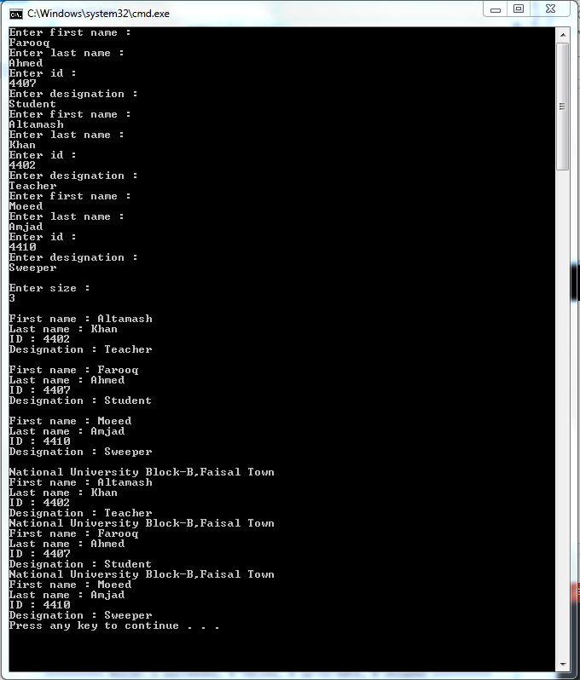

ISSUES
Some minor issues were faced while sorting the list according to the ascending id number and copying the list of faculty member into the university struct.

APPLICATION
Nested structures are applicable to store the broad data into a datatype wisely and efficiently.

CONCLUSION
After this lab session we were to deal with the nested structures and the pointer to the structures.

POSTLAB
#include <iostream>
#include <cmath>
#include <string>
using namespace std;
struct author
{
int id;
string fname;
string lname;
};
void getauthordetails(author & ad)
{
ad;
cout<<"Enter the ID of the author : "<<endl;
cin>>ad.id;
cout<<"Enter the name of the author : "<<endl;
cin>>ad.fname>>ad.lname;
}
struct booklist
{
int code;
string name;
string subject;
double price;
int edition;
};

void getbookdetails(booklist & bl)
{
bl;
cout<<"Enter the bookcode: "<<endl;
cin>>bl.code ;
cout<<"Enter the bookname: "<<endl;
cin>>bl.name;
cout<<"Enter the subject: "<<endl;
cin>>bl.subject;
cout<<"Enter the price of the book: "<<endl;
cin>>bl.price;
cout<<"Enter the edition: "<<endl;
cin>>bl.edition;
}
void displayauthordetails(author ad)
{
cout<<"Author Name: "<<ad.fname<<" "<<ad.lname<<endl;
cout<<"Author ID: "<<ad.id<<endl;
}
void displaybookdetails(booklist bl)
{
cout<<"BookCode: "<<bl.code<<endl;
cout<<"BookName: "<<bl.name<<endl;
cout<<"Subject: "<<bl.subject<<endl;
cout<<"Price: "<<bl.price<<endl;
cout<<"Edition: "<<bl.edition<<endl;
}
int main()
{
author ad;
getauthordetails(ad);
booklist bl1[3];
for(int i=0; i<3; i++)
{
cout<<"Book "<<i+1<<": "<<endl;

getbookdetails(bl1[i]);
}
cout<<endl;
displayauthordetails(ad);
for(int i=0; i<3; i++)
{
cout<<"Book "<<i+1<<": "<<endl;
displaybookdetails(bl1[i]);
cout<<endl;
}

return 0;
}

